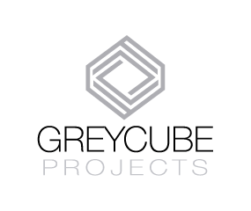
GREY CUBE PROJECTS is a curatorial platform devoted to contemporary Art that establishes multiple transversal interventions within the techno-scientific knowledge. In this exercise, the installation and the site-specific intervention try to be a natural trigger for the spectator.
We work in partnership with different associates and strategic allies (art galleries, art institutions, and academic institutions, among others). We are a multi-disciplinary team led by an independent art curator (John Angel Rodriguez). Our mission is to establish a springboard onto an artist's world, making connections between their work and broader interests as creative thinkers.
GCP is also a non-profit initiative, which independent format enables the creation of curatorial activities devoted to new media — conceiving new media as the exploration of thoughts assisted by the different areas of knowledge. Therefore we execute reciprocal exchanges and collaborations between different cultural agents and artistic spaces in a global context of interaction with an international program of circulation.
Grey Cube Projects is also an itinerant site of cultural production and trans-disciplinary research. The presence in international scenarios is pivotal for the projection of GCP; for this reason, we have created an exchange and residency program that allows us to exchange ideas and join efforts, with similar projects in other latitudes. It is essential to highlight the dynamics of the collaborative work of GCP. We establish partnerships with independent and non-profit initiatives that incorporate alternative models for the creation of artistic projects.
The curatorial proposal developed by GCP incorporates a methodology of observation, outlining artistic processes that tangentially are addressing cross-work methods.
The exhibition displayed in Budapest is entitled "Transversal Intervention", with the conjunction of these two concepts, we are examining ideas derived from language deconstruction and science subjects, with this action, we intend to reflect how these analyses are relevant to the creative production and artistic manifestations. The relevance of this proposal lies in offering a specific profile of curatorship that addresses issues of theoretical and artistic inquiry originated from the transversal intervention between Art, Science and Technology.

